fall 2024
Cse-4355/5355 Electromechanical Systems and Sensors
the university of texas at arlington


lab 3 report
Submitted toward the partial completion of the requirements for CSE 4355/5355
Under the guidance of
Prof. Jason Losh
By:
Dario Ugalde, 1001268068
Joshua Martinez, 1001374818

Introduction
In class, various approaches were discussed to calculate a motor’s speed in rotations per minute, or RPM. This lab focuses on two specific approaches: use of LED diodes and a phototransistor, as well as back emf voltage. Each approach has its benefits, but in circuit design, less components typically result in a cheaper product and less points of failure which is why the back emf approach is more common in practice. This report documents our team’s results of implementing both techniques.

Steps 1 – 3: Circuit Setup
The lab begins as usual with circuit setup by wiring up pins PE4, PC6, and PD0 of our TM4C123GXL microncontrollers running as an analog ADC input, CCP timer counter, and PWM respectively. A 10V power supply positive output was connected to the motor positive input in parallel with 1N5817 Shottky diode to reduce the voltage spike from the decomposing magnetic field of the motor. The negative end of the diode and motor were connected to the drain of an FQP20N06L n-channel power MOSFET. The gate was connected to the to microcontroller’s PWM pin through a voltage divider. Finally, power was applied to the LED and phototransistor to set up for the initial RPM calculation technique. The drawing below demonstrates the initial connections for the circuit:

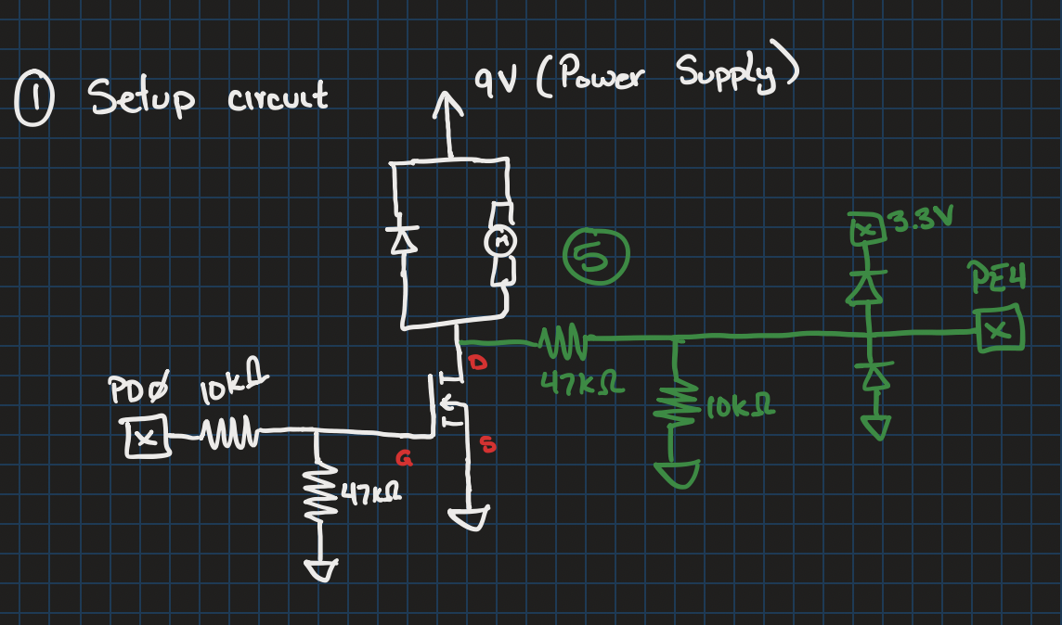
Figure 1: Drawing of LED RPM Circuit

Steps 4 – 5: Calculate Motor RPM
With the circuit connected, code was written for the microcontroller to process input from rotating disk connected to the motor shaft. The disk had 32 slits, which would allow light from the LED diode to reach the phototransistor and increment a counter on the CCP timer. Push buttons SW1 and SW2 were programmed such that inputs on SW1 input would increment the PWM duty cycle by 10% and SW2 decrease by 10%. The UART modules was used to provide user feedback of the current value of the PWM duty cycle. A. timer interrupt was configured to read the number of ticks counted by the CCP at a frequency of 1Hz. This counter value would be multipled by 60 and divided by 32 to get the RPM of the motor at a given PWM duty cycle. This RPM was then provided to the user via UART. Examples of this user feedback are shown below in Figure 3.

Steps 6 – 10: Calculate RPM Via Back-EMF Voltage
The next section of the lab involved extending the code base to support RPM calculation via back EMF voltage. To accomplish this, another timer was configured to capture input from the ADC pin (shown in green in Figure 1). This interrupt momentarily sets the PWM duty cycle to 0 and uses the momentum of the spinning motor to capture an ADC reading from the analog pin before setting the duty cycle back to its previous value. A slight delay of 200μs is used prior to taking the ADC reading to allow the back EMF voltage to stabilize. This second timer triggers at a rate of 50Hz. By taking an estimate of the LED RPM values at each of the 10 points of duty cycle, a linear regression can be taken from the data to form an equation where given a voltage, V, a speed, S, can be calculated. The equation and points used by our team can be seen below in Figure 2:
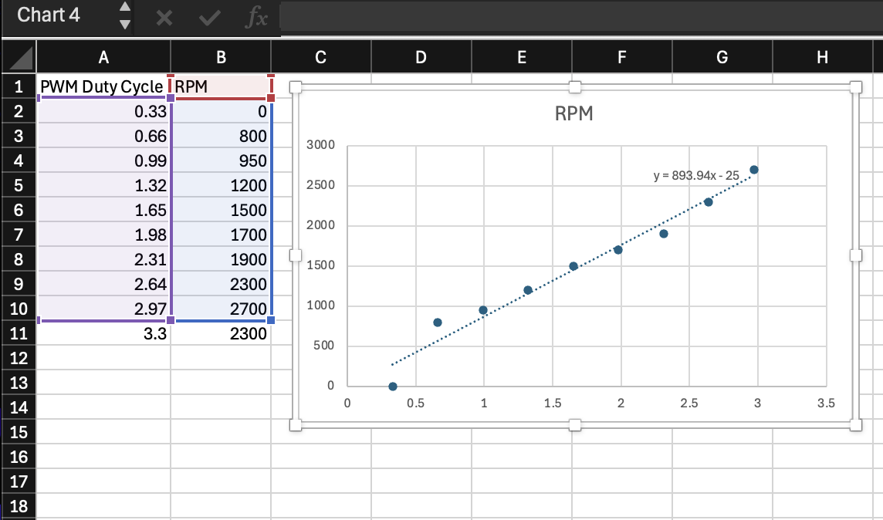
Figure 2: RPM vs. Duty Cycle Line Graph

Conclusion

There are more approaches to calculating RPM values for motors, but this lab served to teach us two simple techniques to calculate the speed of an electric motor. Below are additional captures of the oscilloscope reading captured which demonstrate the back EMF behavior used to calculate the RPM as well as output from the UART module which demonstrate our capture of the back EMF voltage, ADC capture, and back EMF and LED RPM values.

